Curriculum vitae
DOAN THAI SON
PERSONAL DETAILS
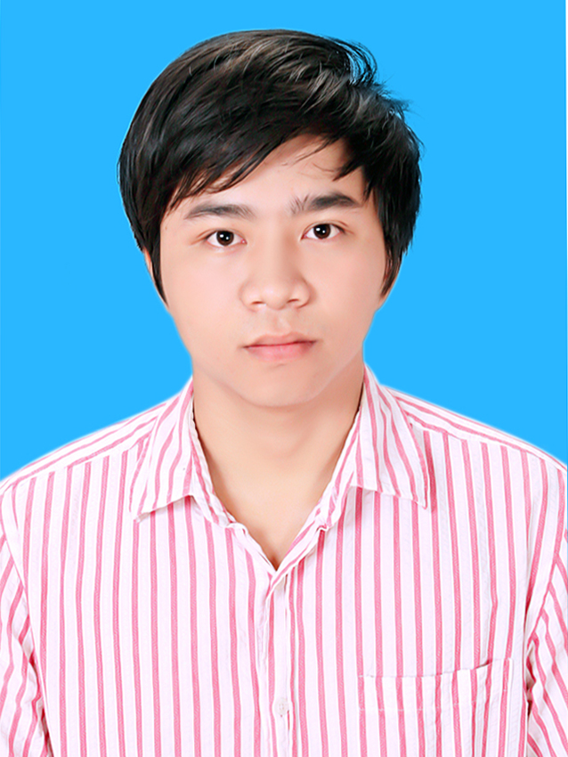 | Full Name : | Doan Thai Son
 | Job Titles: | Junior Software Engineer
 | Date of Birth : | Mar 26th ,1991
 | Place of Birth : | Nam Truc – Nam Dinh – Vietnam
 | Gender : | Male
 | Marital Status : | Married
 | Home Address : | No 302, C8, Nghia Tan urban, Cau Giay district, Hanoi.
 | Skype: | sontrip09
 | Mobile : | (+84) 169 956 5582
 | Email : | thaisonc8@gmail.com

SUMMARY INFORMATION
Experiences in brief: 3 years
- Have 3 years of experience in using Java technologies including JavaSE, JavaEE, Java Script.
- Experiences in Spring, JPA Framwork
- Very good at software analysis and software design as high level design, detail design..
- Using well MySQL, MS SQL, PostgreSQL, Oracle
- Using well Tomcat, Apache
- Have some experiences in ASP.Net, JQuery, C#, C/C++
- Using closely with Eclipse, InteliJ
Strong points: work hard, passion for work, intelligent, communication well, friendly

EDUCATION HISTORY
From: 09/2009  To: 08/2014 | University/School: Hanoi University of Mining and Geology  Degree/Qualifications: Software engineer

EMPLOYMENT HISTORY
From: 09/2014  To: 04/2017 | Company: Center for water resources Software  Job Title: Junior Software Engineer  Job Description: This I worked for CWRS - Center for water resources Software when I was left University. In this company, I joined team to research, develop, trainning … Manage project of New contryside which along with government portal helps the government to management and process all procedures .

SIGNATURE
I certify that the information declared above is true to the best of my knowledge and belief.
Signature

Doan Thai Son

APPENDIX - PROJECT REFERENCE AND SKILL SET
ATTENDED PROJECTS
From: 01/2017  To: 04/2017 | Project Name: | ACEO
From: 01/2017  To: 04/2017 | Company: | Center for water resources Software
From: 01/2017  To: 04/2017 | Client: | Company
From: 01/2017  To: 04/2017 | Project size: | 30 mans-month
From: 01/2017  To: 04/2017 | Position: | Developer
From: 01/2017  To: 04/2017 | Responsibilities: | Research and develop
From: 01/2017  To: 04/2017 | Project Description: | This project included two parts, client side was built on C# and server side was built on JavaEE. I develop in server side.
From: 01/2017  To: 04/2017 | Used Programming Languages: | Java
From: 01/2017  To: 04/2017 | Used Technologies: | Server Platform: Window Server  Client Platform: Web  Database: PostgreSQL  Frameworks: AngularJS, JPA  Development Tool: Eclipse
From: 06/2015  To: 12/2015 | Project Name: | Manage Project of New contryside
From: 06/2015  To: 12/2015 | Company: | Center for water resources Software
From: 06/2015  To: 12/2015 | Client: | Anyone who need to build newcontryside
From: 06/2015  To: 12/2015 | Project size: | 24 mans-month
From: 06/2015  To: 12/2015 | Position: | Developer
From: 06/2015  To: 12/2015 | Responsibilities: | Research and develop
From: 06/2015  To: 12/2015 | Project Description: | Manage project of New contryside
From: 06/2015  To: 12/2015 | Used Programming Languages: | Java
From: 06/2015  To: 12/2015 | Used Technologies: | Server Platform: Window Server  Client Platform: Web  Database: PostgreSQL  Frameworks:  Development Tool:, Eclipse, IntelliJ

INFORMATION TECHNOLOGY SKILLS
Experiences: |  | 0: 0 month | 2: 6 – 12 months
 |  | 1: 1 – 6 months | 3: 1 – 2 years
Last used: |  | Last year used
Expert level: |  | 1: Beginner Level | 3: Sometimes have to use manuals |  |  | 5: Expert Level
 |  | 2: Always have to use manuals | 4: Can solve problems
 |  |  | Experiences | Last used | Expert level
 |  |  | Experiences | Last used | 1 | 2 | 3 | 4 | 5
Platform
 | Linux |  | 1 | 2014 | x
 | Mac |  | 1 | 2015 |  | x
 | Windows |  | 3 | 2017 |  |  |  |  | x
Database
 | Oracle |  | 1 | 2016 |  | x
 | MS SQL Server |  | 1 | 2015 |  |  | x
 | MySQL |  | 1 | 2016 |  |  | x
 | PostgreSQL |  | 3 | 2017 |  |  |  | x
Web Application server
 | Apache |  | 2 | 2017 |  |  | x
 | TomCat |  | 2 | 2017 |  |  | x
 | GlassFish |  | 1 | 2017 |  |  | x
Programming
 | Java/JavaEE |  | 3 | 2017 |  |  |  | x
 | C/C++ |  | 1 | 2015 |  |  | x
 | C#.NET |  | 1 | 2016 |  | x
 | PHP |  | 1 | 2015 | x
 | ASP.NET |  | 1 | 2016 | x
 | JavaScript |  | 3 | 2017 |  |  |  | x
 | XML/XSL |  | 1 | 2017 | x
Frameworks/Middleware
 | JSF |  | 1 | 2015 | x
 | Struts |  | 1 | 2015
 | Spring |  | 1 | 2016 |  |  | x
 | Hibernate/JPA |  | 2 | 2017 |  |  | x
 | J2EE/EJB |  | 1 | 2017 |  |  | x
Tools
 | Rational Rose |  | 3 | 2017 |  |  | x
 | Eclipse |  | 3 | 2017 |  |  |  | x
 | IntelliJ |  | 3 | 2017 |  |  |  |  | x

FOREIGN LANGUAGE
Experiences: |  | 0: 0 month | 2: 6 – 12 months
 |  | 1: 1 – 6 months | 3: 1 – 2 years
Last used: |  | Last year used
Expert level: |  | 1: Beginner | 3: Fluent |  |  | 5: Translator
 |  | 2: Conversational | 4: Expert
 |  |  | Experiences | Last used | Expert level
 |  |  | Experiences | Last used | 1 | 2 | 3 | 4 | 5
Languages
 | English |  | 2 | 2016 |  |  | x

